Schematic:

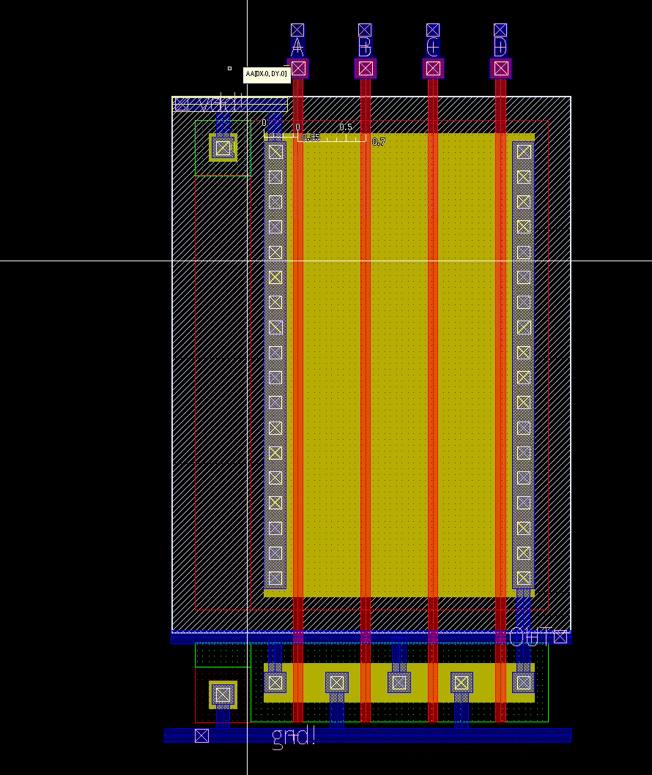

DRC

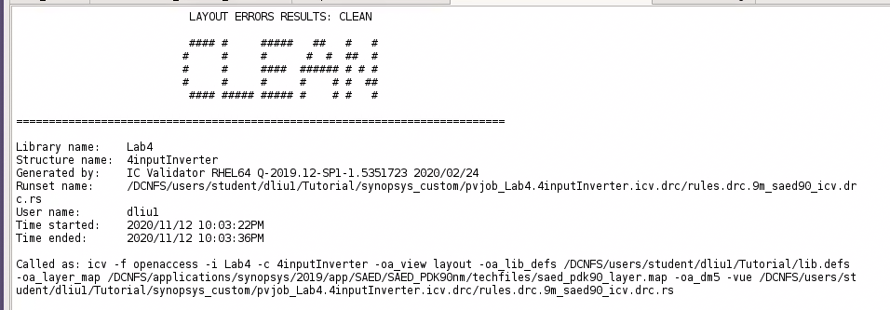

Questions:

To optimize results, you can shrink the distance between the polysilicon and diffusion layers. You can also shrink the area of the metal in the inputs and outputs.

Conclusion:

You can optimize results in a layout by reducing excess area in certain areas.